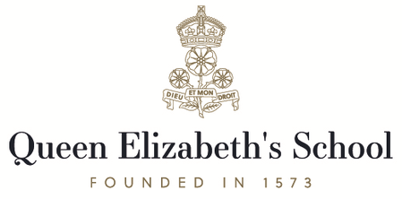

**Gift Aid Declaration Form**

I am a UK taxpayer, and wish Queen Elizabeth's School to claim Gift Aid on all donations I have made in the last four years and any future donations I make. I confirm I have paid or will pay an amount of Income Tax and/or Capital Gains Tax for each tax year (6 April to 5 April) that is at least equal to the amount of tax that all the charities or Community Amateur Sports Clubs (CASCs) that I donate to will reclaim on my gifts for that tax year. I understand that if I pay less income tax in the current tax year than the amount of Gift Aid claimed on all of my donations it is my responsibility to pay any difference. I understand that other taxes such as VAT and Council Tax do not qualify. I understand the charity will reclaim 25p of tax on every £1 that I give or have given in the last four tax years.

Name of Charity:

Name:

Address:

Email:

Mobile:

Amount: